1.INTRODUTION

1.1 OVERVIEW

A resume summary is a short description of your qualifications that explain why you're a good fit for the role. Analytically-driven Maintenance Mechanic with 5+ years of experience focusing on the intricacies of equipment and instrumentation. Highly adaptable and dedicated to producing error-free results, safe working.

1.2 PURPOSE

The goal and overall purpose of a resume is to introduce your qualifications and skills to employers. It's an informational document that tells your career story, outlining all details in an easily read format. Resumes also hold meaning within themselves

2.PROBLEM DEFINITION&DESIGN THINKING

2.1 EMPATHY MAP

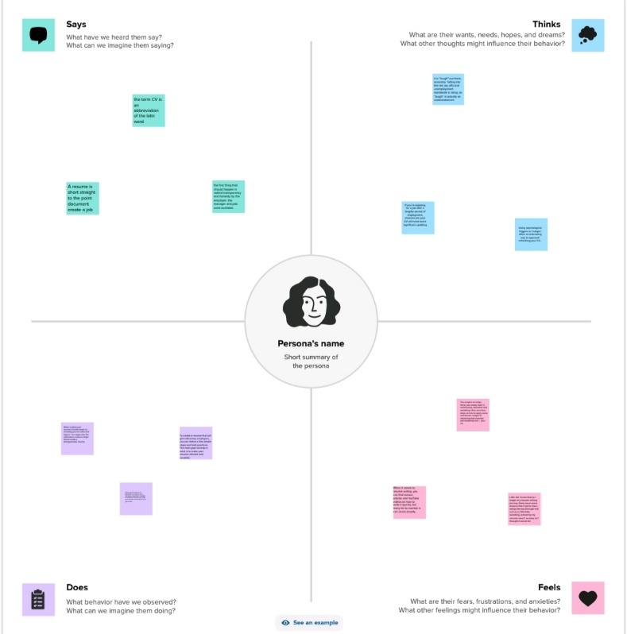

2.2 IDEATION &BRAINSTROMING MAP

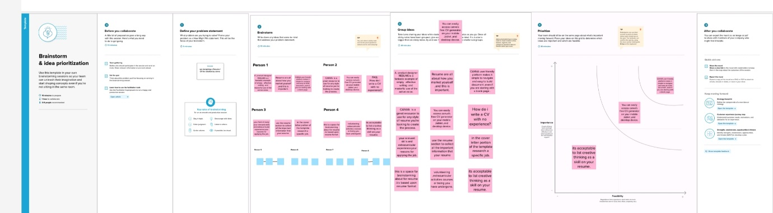

3.RESULT

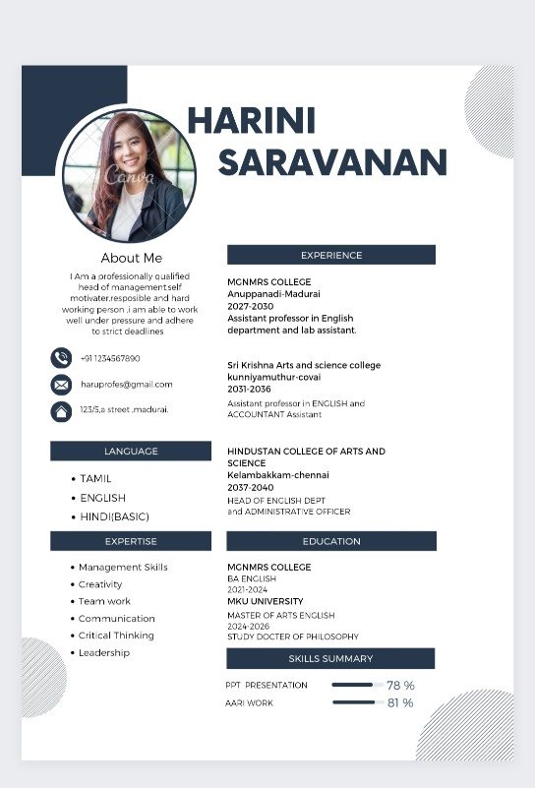

4.ADVANTAGES&DISADVANTAGES

**Advantages**

* Popular
* Logical flow and easy to read
* Showcases skill growth and responsibility
* Shows promotions and titles, as well as company

**Disadvantages**

* Emphasizes gaps in jobs
* Highlights frequent job changes
* Does not emphasize skill development
* Emphasizes career changes, especially unrelated jobs
* Points out career setbacks

5 .APPLICATIONS

I have used MURAL Application and CANVA Applications.

6 .CONCLUSION

We have created resume/cv with the help of CANVA

7 .FUTURE SCOPE

We were planning to join the graphic designing course.